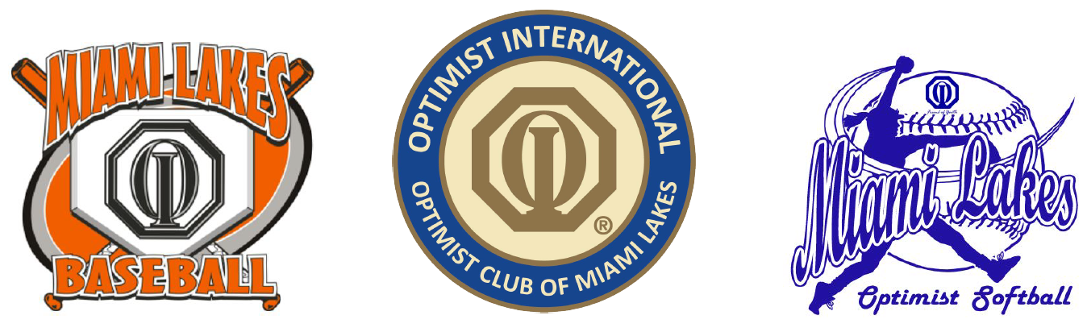

The Optimist Club of Miami Lakes is run completely by volunteers; no money is spent on the administration of the program. The organization is indebted to its sponsors and benefactors and is continually looking for donations to better the program and to better serve the youth of our community. With your help, and the work of our dedicated volunteers and parents, we can keep the registration fees for the children to a minimum. The baseball and softball programs cover the ages from 4 to 16 years old. We rely heavily on our sponsors to provide our children with the best quality and safest equipment available.
Below are our current sponsorship packages. Please check off the package of your choice and provide the contact information requested below. If the digital sign option is selected, include artwork for your company in a jpeg, png, or eps format. You may also email a business card if artwork is not available in digital format.
Hall of Fame Package $2,000  Exclusive Package for one sponsor  Package Selected | For two consecutive seasons, your company name will grace the backs of one of our youth teams. A sponsorship plaque with the team photo is included. An exclusive web banner on our sports website will provide a direct link to your website. Your company logo will be displayed on our digital sign 24/7 for the two seasons. Monthly mentions on our Instagram site.
Triple Crown Package $750  Package Selected | For one season, your company name will grace the backs of one of our youth teams. A sponsorship plaque with the team photo is included. Your company logo will be displayed on our digital sign 24/7 for one season. Monthly mentions on our Instagram site. Inclusion in sponsor’s slideshow on our website.
MVP Package $500  Package Selected | For one season, your company name will grace the backs of one of our youth teams. A sponsorship plaque with the team photo is included. Your company logo will be displayed on our digital sign 24/7 for one season.
Grand Slam Package $350  Package Selected | For one season, your company name will grace the backs of one of our youth teams. A sponsorship plaque with the team photo is included.

Company Name: Contact Name:
Company address: Telephone
Email Address: Company Website URL:
Team Name: Team Head Coach:

Please make the check out to Optimist Club of Miami Lakes. Mail a check and this sheet with your circled selection to:
Optimist Club of Miami Lakes 6411 NW 162ND ST, Miami, Lakes FL 33014. Credit card payments accepted via PayPal. Note: The PayPal service fee will be added to your invoice. Email info@ocml.org for invoice instructions.

